WEDE5020

ST10472230

LUKE CLOETE

GROUP 1

Table of Contents

Proposal Content: 3

1) Organisational Overview: 3

2) Website Goals and Objectives: 3

3) Current analysis 4

Strengths: 4

Weaknesses: 4

4) Proposed Website Features and functionality: 4

Homepage: 4

About us 4

Contact page: 4

Products/services: 4

Enquiry: 4

5) Design and User Experience: 5

6) Technical requirements: 5

7) Timeline and Milestones: 5

Website coding: 5

Image sourcing: 5

Proposal content: 6

8) Budget: 6

Development: 6

Hosting: 6

Maintenance: 6

References: 6

Images: 6

# Proposal Content:

## 1) Organisational Overview:

Organisation Name: Bullish Kicks

Bullish kicks have been inspired by the forex market. The name bullish indicates an everlasting growing market, hence the name bullish kicks. We have been founded in 2025 as we have finally decided to open our stores and sell the most recognizable kicks in South Africa.

Our Goal and Mission for Bullish Kicks is to ensure that we are the leading shoe retail business within South Africa that can bring the latest and most rare kicks to you. We hope that our clients will value and love our incentives we offer as well when they sign up for the Bullish Community updates.

Bullish Kicks does not have a target audience as we believe there is no age to love shoes. If anything, we hope that all ages will shop at our stores and build a relationship with client and employee.

## 2) Website Goals and Objectives:

One of our main goals is to monitor the traffic of how many views our website has and sign up for community updates or by following our social media pages. This is important to us as it will help us understand whether the consumers love our branding image or not.

One of the ways we can determine whether we are successful in doing so is to monitor traffic rates on the website and to create a source of feedback by our clients to identify the strengths and weaknesses of the business.

## 3) Current analysis

Strengths: Website is very unique

UX is very smooth and operational

Clients would want to visit the website again

Weaknesses: Does not support an online cart feature for online shopping

Create a geographic feature to locate clients to the nearest store

Having identified areas of strengths or weaknesses, I believe that these are things that we could improve on more and tackle effectively. Mainly our cart system within the business so that clients can buy and ship products to their desired location.

## 4) Proposed Website Features and functionality:

Homepage: Our homepage is one of our main features we have worked on as this ensures that clients will see our unique branding and be captivated by our creativity.

About us: Our About us page tells our clients a little about the business and what Our values for the business are why we founded the company.

Contact page: Our Contact page gives our consumer our location where we are based as well as our contact details for further assistance.

Products/services: Our products and services pages give our clients a look at what we have to offer and what we will bring to stores soon as well.

Enquiry: Our Enquiry is a form set out on our website to ensure that our clients can lodge a complaint, or anything related to a place of importance.

All these play a crucial role in us having our clients have a unique experience with our website layout. As each page directs our clients to its desired source of information which they are looking for.

## 5) Design and User Experience:

I choose a dark theme using the colours black and light grey as the two primary sources of the colour theme for the website. This was to ensure that the website is not too over coloured by different colours making the website colourful and unpleasant for the user to look at.



I used Arial as a font as it made the website look more professional rather than

other fonts.

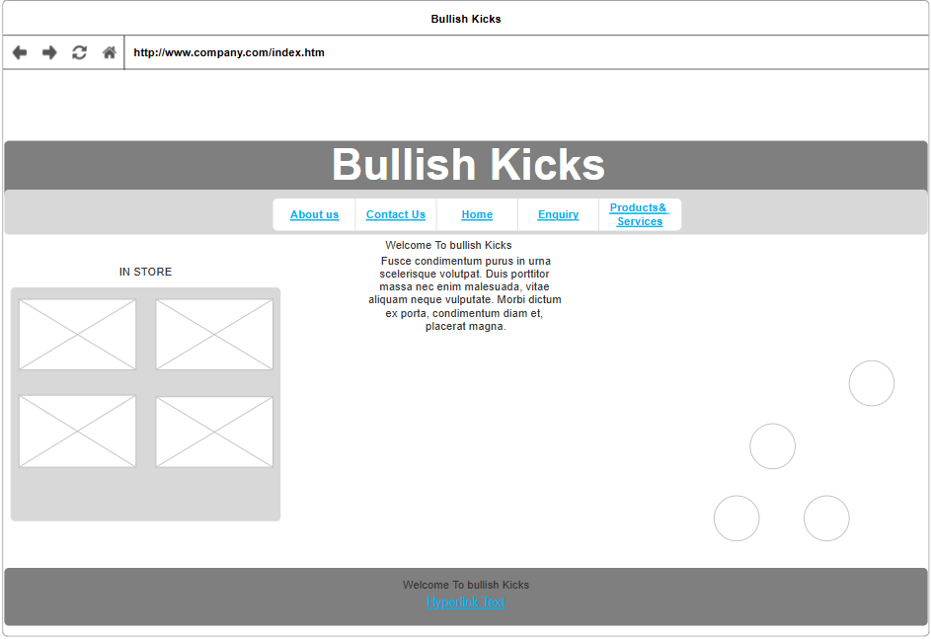

For the Layout I chose a unique layout style, ensuring that the homepage held a minimalistic look while also holding onto its unique branding. This was by separating products and navigation attributes to its own desired positions. I choose the same colour schemes for the navigation bar and colour pallet throughout the entire website design process. This was to ensure that the branding remained a sense of dark, mysterious and unique branding.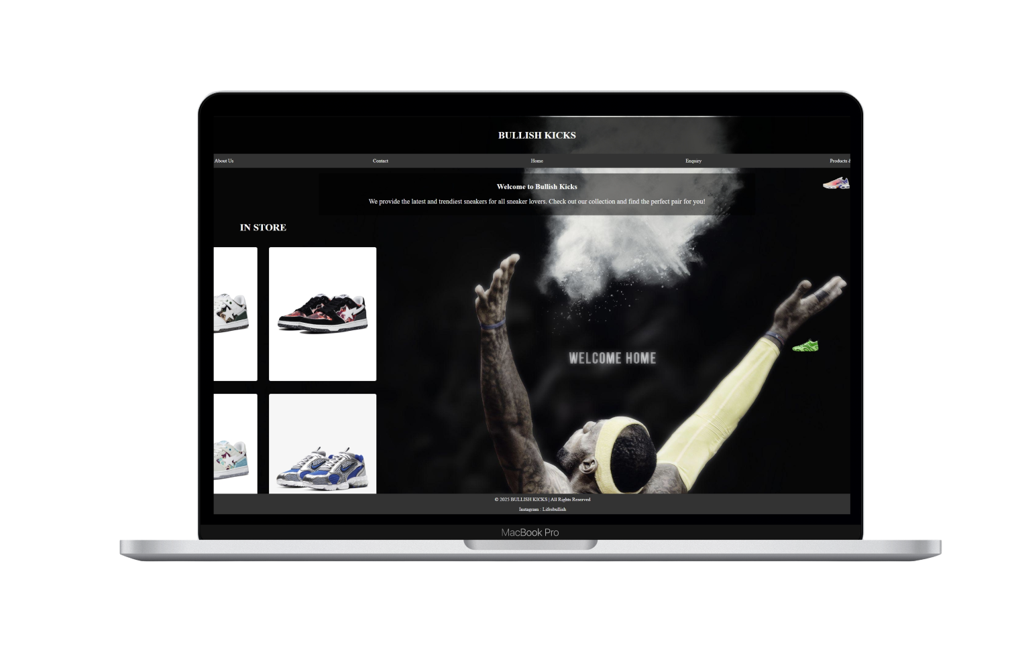

## 6) Technical requirements:

The coding will consist of HTML, CSS to create functionality and to ensure that the website is created in the most effective way.

## 7) Timeline and Milestones:

Website coding: 2 days (March 21 – March 22)

Image sourcing: 1 day (March 21)

Proposal content: 2 days (March 29 –March 30)

## 8) Budget:

Development: Due to CSS and UX being the main features of the website will consist of Our design Cost of R3000 and Web designment of R3500 as well as to focus on this will cost around R6500

Hosting: Hosting will cost an additional amount of R1500 as we will use AWS services to store client's data onto the cloud rather than physical services

Maintenance: Maintenance will cost R2500 as this will ensure that the website does

not enter any errors or clients not being able to access the website.

Total cost: R10 500

# References:

## Images:

folder{Bounce}

<https://www.nike.com/za/>

folder{images}

<https://www.bapesouthafrica.co.za/>

<https://ie.pinterest.com/pin/lebron-james-basketball-gif-find-share-on-giphy--772719248567869430/>

<https://x.com/World/photo>

folder{images bape black}

<https://int.bape.com/products/bape-men-low-sneakers-bape-sk8-sta-3-m2-0zxshm191315o?variant=44260313694381>

folder{images bape white}

<https://int.bape.com/products/bape-men-low-sneakers-bape-sk8-sta-3-m2-0zxshm191315o?variant=44260313923757>

folder{images nike}

<https://www.nike.com/za/t/air-zoom-spiridon-cage-2-shoe-Jkd53w/CJ1288-002?cp=31184631024_search_&Macro=--g-10714444208-105339677483--c-EN-gsproducts-453305189882-pla-333563063466-1028745-00194272011908&ds_rl=1252249&gad_source=1&gclid=Cj0KCQjwna6_BhCbARIsALId2Z1bXE4fKDcsSro4oZ71U_j3C35AkqKIYTwAlSFKsiabib5OwW_ZydUaAvHiEALw_wcB&gclsrc=aw.ds>

folder{lebron}

<https://wallpapers.com/wallpapers/athlete-s1c05yk6o973k2a5.html>

<https://wall.alphacoders.com/big.php?i=782694>

<https://wallpapercave.com/lebron-james-nike-wallpapers>